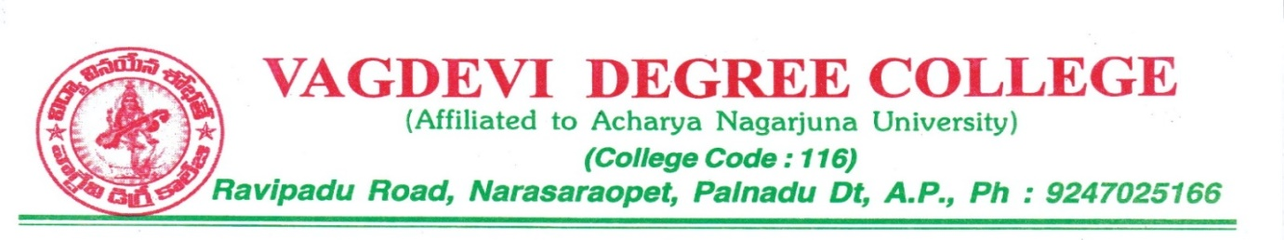

vagdevi Degree college

POLICY FOR MAINTAINING FACILITIES

VAGDEVI DEGREE COLLEGE Narasaraopet

(Affiliated to Acharya Nagarjuna University
& Permitted by APSCHE, Govt. of A.P)
Ravipadu Road,Narasaraopet-522601.Guntur Dt. A.P

POLICIES FOR MAINTAINING AND UTILIZING PHYSICAL, ACADEMIC AND SUPPORT FACILITIES
- The college ensures optimal allocation and utilization of the available financial recourses for maintenance and upkeep of different facilities by holding regular meetings of various committees constituted for this purpose as per the requirements in the interest of students.
- Laboratory: Record of maintenance account is maintained by Lab Technicians, Lab In charge and supervised by HODs of the concerned departments.
- Maintenance of laboratories are as follows: - The calibration, repairing and maintenance of sophisticated lab equipment's are done by the technicians of related owner enterprises.
Library:

- The requirement and list of books is taken from the concerned departments and HOD's are involved in the process. The finalized list of required books is duly approved and signed by the principal.
- Suggestion box is installed inside the library room to take users feedback. Their continuous feedback helps a lot in introducing new ideas regarding library enrichment.

- To ensure return of books, 'no dues' from the library is mandatory for students before appearing in exam.
- Other issues such as weeding out of old titles, schedule of issue/ return of books etc. are chalked out / resolved by the library committee.
Sports:

Regarding the maintenance of sports equipment in the college physical director is deputed. College participated in various indoor and outdoor sports competitions organized inside and outside college.
Computers:
- Centralized computer center established to enrich the students.

- Each department having appropriate computer for their requirements.

- Internet and WIFI Enabled campus.

- Open access journals facilities are available.

Classrooms:

- The college has various committees for maintenance and upkeep of infrastructure. At the departmental level, HODs submit
their requirements to the principal regarding classroom furniture and other.

- Administrative officers will take in charge for student's academic requirements.
Additionality:

- There are lab assistants in every department, who maintains the stock register by physically verifying the items round the year.

- Department wise annual stock verification is done by concerned Head of the Department.

3. Regular maintenance of Computer Laboratory equipment's is done by Laboratory Assistant along with Laboratory attendant and they are headed by the faculty in charge.
4 Regular cleaning of water tanks, proper garbage disposal, pest control, landscaping and maintenance of lawns is done by Institute
concern Employees.

- College campus maintenance is monitored through regular inspection.

- Outsourcing is done for maintenance and repairing of IT infrastructure such as computers, internet facilities including Wi-Fi and broadband.
7. Updating of software's is done by lab assistants.

- Maintenance is done for the maintenance of wooden, furniture, electrification, and plumbing.

- Regular maintenance of the water cooler and water purifier is done regularly. The maintenance of the reading room and stock verification of library books is done regularly by library staff.

Principal

