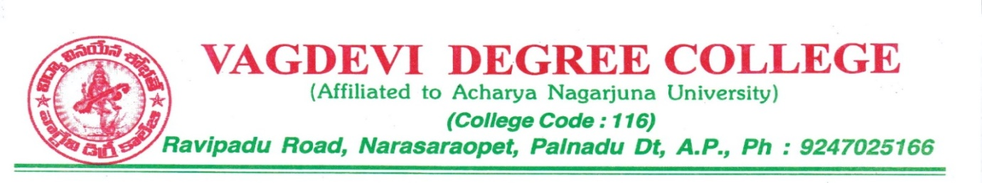

vagdevi Degree college

Code of conduct
Policy
Principal / Director

VAGDEVI DEGREE COLLEGE Narasaraopet

(Affiliated to Acharya Nagarjuna University
& Permitted by APSCHE, Govt. of A.P)
Ravipadu Road,Narasaraopet-522601.Guntur Dt. A.P
Code of Conduct for Principal/Director
- The principal is the academic and administrative Final Authority of the institute and works for the growth of the institute. He/She will Introduce the policies approved by the highest decision-making body of the college. He/She shall Maintain coordination among Different statutory committees and non-statutory bodies including Academic Council.
- The principal is the academic and administrative Final Authority of the institute and works for the growth of the institute. He/She will introduce the policies approved by the highest decision-making body of the college. He/She shall maintain coordination among Different statutory committees and non-statutory bodies including Academic Council.
- He/She is the ex-officio member of Board of Governors, Chairman of Academic Council, Chairman of the finance committee and also Chief Controller of Examinations. He/She Supervises admissions, examinations, evaluation for smooth functioning of the system.
- He/She is Vested the Power to nominate Coordinators, Convenors and other administration functionaries in the administration, with the approval of the Academic Council.
- He/She conducts the meetings of the Governing Body as per Set for the guidelines.
- He/She holds Academic meetings as per the norms.
- Coordinates and motivates the faculty, administrative authorities and the supporting staff, so as to fulfill their respective roles more effectively.
- • Works to reach the common goal to providing effective education and guide to enable the students to from out promising career and lifelong learning.
- In the matters related to decision implementation, Principal will be assisted by the Governing Body and Academic Council of the college.
- In matters of admissions, the principal will be supported by Coordinator Admissions.
- In matters related to academic work, he/she will be assisted by the Heads of the Departments as well as Co-ordinations.
- Shall closely monitor the class work as per the timetables and the academic calendar with assistance of faculty in-charges.
- Shall closely observe various academic activities like conduct of conferences, seminars, workshops etc.
- Shall hold meetings of the heads of departments to review the progress of the academic work and suggest effective measures to achieve desired academic Results.
- Shall instruct, if necessary, the heads of the departments to conduct remedial classes academically to support the slow learners.
- In matters related to internal examinations, semester end examinations (both theory and practical), result analysis, detained candidates, Principal will be assisted by Controller of examinations and additional controllers of the college.
- Principal shall also ensure quality assurance and he/she should be assisted by coordinator IQAC.
- Should promote industry-institute interaction for better employability of the students.
- Shall promote internal revenue generation activities with the help of staff and students.
- Arrange finishing school for the students with the active association of Convenor Placement and Counselling cell.
- Shall make efforts to look after the overall welfare of the staff and students.
- Shall forward monthly salary bills of all staff members of the college to the finance department for necessary action.
- Shall countersign all kinds of scholarship bills in respect of the students of the college.
- Shall have powers to sanction the purchase of stationary, library books, periodicals, consumables for laboratories, etc. subject to the limit of powers delegated in respective areas and subject to the prescribed procedures, budget provisions under the respective heads of the budget.
- Shall countersign T.A bills.
- Shall have powers to sanction advances and final withdrawal of GPF of the staff.

Principal

